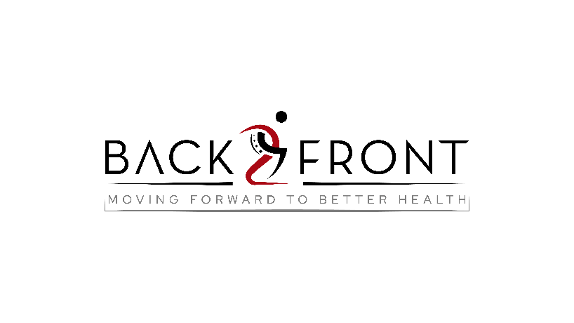

**Bring a Friend Week (19-24th August)**

**Terms and Conditions**

**Massage: 2-for-1 Massage Special**

1. The 2-for-1 massage special is valid for a 30-minute massage session for both the referrer and their friend when booked together.
2. To extend the session, an additional fee applies:
   * 45-minute session: £10 extra per person.
   * 60-minute session: £15 extra per person.
3. The referrer and their friend can book their sessions at different dates and times but must book and attend their sessions within the validity period.
4. This offer is valid only during "Refer a Friend Week" from Monday, August 19th to Saturday, August 24th.
5. Bookings are subject to availability and must be made in advance.
6. The offer cannot be combined with any other promotions or discounts, including massage membership discount.
7. Cancellation or rescheduling must be done at least 24 hours in advance. Late cancellations or no-shows will result in forfeiture of the offer.
8. This offer is non-transferable and has no cash value.

**Physio: 50% Off Initial Assessment**

1. The 50% off initial assessment offer is available to friends of current clients only.
2. The discounted assessment must be booked and completed during "Refer a Friend Week" from Monday, August 19th to Saturday, August 24th.
3. The friend must mention the referral at the time of booking to receive the discount.
4. This offer is valid for first-time physiotherapy assessments only.
5. Bookings are subject to availability and must be made in advance.
6. The offer cannot be combined with any other promotions or discounts.
7. Cancellation or rescheduling must be done at least 24 hours in advance. Late cancellations or no-shows may result in forfeiture of the offer.
8. This offer is non-transferable and has no cash value.

**PT: Free Small Group Personal Training Session**

1. The free small group personal training session is available to friends who are brought in by current clients.
2. The session must be booked and attended during "Refer a Friend Week" from Monday, August 19th to Saturday, August 24th.
3. Group size may vary; please check availability at the time of booking.
4. Both the referrer and their friend(s) must book the session together.
5. This offer is valid for one free session per friend and cannot be used for multiple sessions.
6. The offer cannot be combined with any other promotions or discounts.
7. Cancellation or rescheduling must be done at least 24 hours in advance. Late cancellations or no-shows may result in forfeiture of the offer.
8. This offer is non-transferable and has no cash value.

**Classes: Free Class**

1. The free class offer is available to friends of current clients.
2. The friend must not have attended the same class previously.
3. The free class must be booked and attended during "Refer a Friend Week" from Monday, August 19th to Saturday, August 24th.
4. This offer is valid for one free class per friend and cannot be used for multiple classes.
5. Bookings are subject to availability and must be made in advance.
6. The offer cannot be combined with any other promotions or discounts.
7. Cancellation or rescheduling must be done at least 24 hours in advance. Late cancellations or no-shows may result in forfeiture of the offer.
8. This offer is non-transferable and has no cash value.